ПРИМЕР ПЕРЕВОДА ДИПЛОМОВ И ПРИЛОЖЕНИЙ К НИМ

Образец диплома о высшем образовании
(на русском и английском языке)

┌────────────────────────────────────┬────────────────────────────────────┐
│ │ │
│ РЕСПУБЛИКА БЕЛАРУСЬ │ REPUBLIC OF BELARUS │
│ │ │
│ ДИПЛОМ О ВЫСШЕМ ОБРАЗОВАНИИ │ DIPLOMA OF HIGHER EDUCATION │
│ │ │
│ ДИ N 0000000 │ ДИ No. 0000000 │
│ │ │
│Настоящий диплом выдан _____________│This diploma is issued to __________│
│____________________________________│____________________________________│
│____________________________________│____________________________________│
│в том, что _________ в 20__ году │to certify that he (she) in 20__ │
│ (он, она) │entered ____________________________│
│поступил__ в _______________________│____________________________________│
│____________________________________│____________________________________│
│____________________________________│____________________________________│
│____________________________________│____________________________________│
│и в 20__ году окончил__ полный курс │and in 20___ completed the full │
│____________________________________│course _____________________________│
│____________________________________│____________________________________│
│____________________________________│____________________________________│
│по специальности ___________________│having specialized in ______________│
│____________________________________│____________________________________│
│____________________________________│____________________________________│
│____________________________________│____________________________________│
│Решением государственной │By the Decision of the State │
│экзаменационной комиссии от │Examination Board │
│__ _________________ 20__ г. │issued ______________ __, 20__ │
│протокол N _________________________│minutes No. ________________________│
│присвоена квалификация _____________│is qualified as ____________________│
│____________________________________│____________________________________│
│Настоящий диплом дает право на │By this diploma he (she) is │
│самостоятельное выполнение всех │entitled to carry out any │
│работ, связанных с полученными │professional activities connected │
│квалификацией и специальностью. │with the above-mentioned │
│ │qualification and │
│Председатель государственной │speciality/specialization. │
│экзаменационной комиссии │Chairperson of the State │
│ │Examination Board │
│Место Руководитель учреждения │Seal │
│для фото образования │Head of the Educational Institution │
│и печати │ │
│ Декан (начальник) │Dean (Head) of the Faculty │
│ факультета │ │
│ │ │
│Город _________ __ _________ 20__ г.│City________ _________ ___, 20___ │
│Регистрационный N __________________│Registration No. _________________ │
└────────────────────────────────────┴────────────────────────────────────┘

Образец приложения к диплому о высшем образовании

Supplement to Diploma A № 0888274

Academic Transcript
(not valid without Diploma)

__________________________________
(Full Name)

within the course of studies at the educational institution “Belarusian State University of Informatics and Radioelectronics”, Faculty of ______________ from September 01, 2008 till June 30, 2013 having specialized in “_______________”, specialization “___________________” studied the following subjects and had shown the following academic performance:

No. | Subjects | Total Number of Academic Hours | Marks
 |  |  | Exam | Credit
1.
2.
3.
No. | Term Papers (Works) | Total Number of Academic Hours | Marks
1.
2.
3.
No. | Practical Trainings | Total Number of Academic Hours | Marks
1.
2.
3.

Passed State Examination in the speciality “________________”, specialization “_________________” with the mark “_________”.

Presented a diploma paper (project) on the topic “________________” and defended it with the mark “______”.

Vice-Rector for Education and Quality Management | /stamped and signed/ | ________
Faculty Dean  Faculty Secretary | /signed/  /signed/ | _______  _______
City Minsk, June 30, 20___ Registration No. ____

Translation is correct.
BSUIR International Relations Department Head Elena Bakunova

Образец справки об обучении

___________________________________________________________________________
(полное официальное наименование учреждения образования, иной организации,
индивидуального предпринимателя, которым в соответствии с законодательством
предоставлено право осуществлять образовательную деятельность)
___________________________________________________________________________

СПРАВКА ОБ ОБУЧЕНИИ
А N 0000000

Выдана _______________________________________________________________
(фамилия, собственное имя, отчество (если таковое имеется)
в том, что он (она) осваивал(а) ___________________________________________
(наименование образовательной программы)
___________________________________________________________________________
___________________________________________________________________________
с __ __________ 20__ г. по __ ___________ 20__ г.

Справка выдана в связи с отчислением
___________________________________________________________________________
(основания отчисления, дата и номер решения)

Руководитель учреждения образования,
иной организации, индивидуального
предпринимателя ____________________ _______________________
(подпись) (инициалы, фамилия)
М.П.
Город ___________ __ ___________ 20__ г.

Belarusian State University of Informatics and Radioelectronics
full official name of the educational institution, other organization or sole proprietor
which is legally entitled to conduct educational activity

ACADEMIC CERTIFICATE

A No. 0000000

is issued to _____________ and herewith certifies that he has been taking a first-degree programme in ________________, Faculty of ________________. Mode of study is _________. Period of study is from ________ till ____________.
This certificate is issued due to the fact of expel from the university at his own request under the Rector’s order No. ____ dated _______.

No. | Subjects | Total Number of Academic Hours | Marks
 | 1st semester
1.
2.
 | 2nd semester
1.
2.
Director of the educational institution,
other organization or sole proprietor /seal, signature/
Dean /signature/
Secretary /signature/
Registered under No. ___ dated _______, in Minsk.

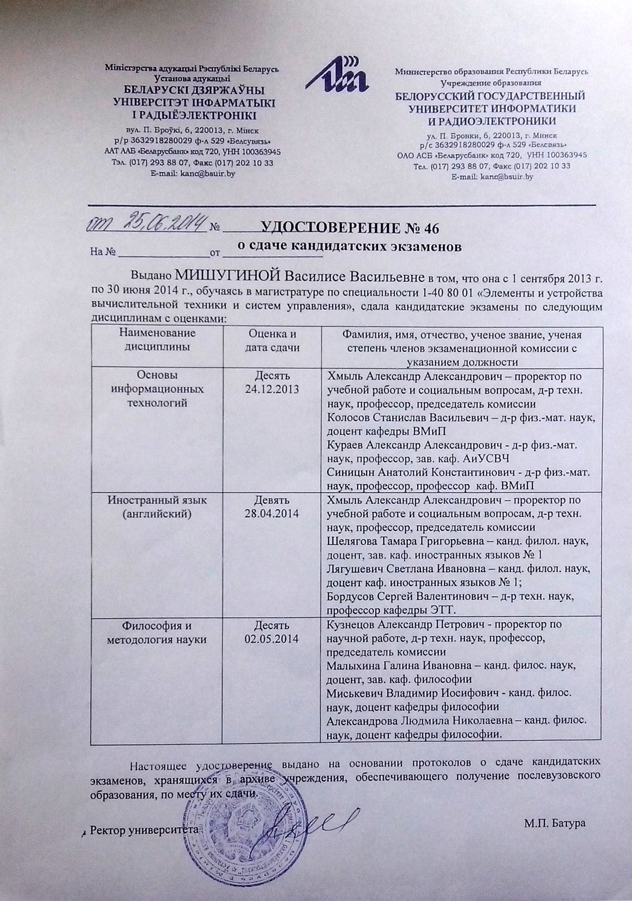

Ministry of Education of the Republic of Belarus
Educational Institution
BELARUSIAN STATE UNIVERSITY OF INFORMATICS AND RADIOELECTRONICS
CERTIFICATE № 46 on PhD Candidacy Examinations
dated June 25, 2014

This is to certify that VASILISA MISHUHINA studied at the Master’s Degree course No. 1-40 80 01 “Components and Devices of Computers and Control Systems” from September 1, 2013 till June 30, 2014 and passed qualifying examinations for admission to PhD studies with the following marks:
Subjects | Mark and  examination date | Full names, academic titles and degrees, positions  of the examination commission members
Basics of Information Technologies | 10 (TEN)  24.12.2013 | Khmyl A. – Vice-Rector for Education and Social Affairs, Dr. Sc. (Eng), Prof., Commission Chair  Kolosov S. – Dr. Sc. (Phys.-Math.), Assoc. Prof., Department of Computational Methods and Programming  Kurayev A. – Dr. Sc. (Phys.-Math.), Prof., Head of Department of Antennas and UHF Devices  Sinitsyn A. – Dr. Sc. (Phys.-Math.), Prof., Department of Computational Methods and Programming
Foreign Language (English) | 9 (NINE)  28.04.2014 | Khmyl A. – Vice-Rector for Education and Social Affairs, Dr. Sc. (Eng), Prof., Commission Chair  Shelyagova T. – Cand. Sc. (Philol.), Assoc. Prof., Head of Department of Foreign Languages No. 1  Lyagushevich S. – Cand. Sc.(Philol.), Assoc. Prof., Department of Foreign Languages No. 1  Bordusov S. – Dr. Sc. (Eng), Prof., Department of Electronic Technology and Engineering
Philosophy and Methodology of Science | 10 (TEN)  02.05.2014 | Kuznezov A. – Vice-Rector for R&D, Dr. Sc. (Eng), Prof., Commission Chair  Malykhina G. – Cand. Sc. (Philos.), Prof., Head of Philosophy Department  Miskevich V. – Cand. Sc. (Philos.), Assoc. Prof., Philosophy Department  Alexandrova L. – Cand. Sc. (Philos.), Assoc. Prof., Philosophy Department
This certificate is issued on the basis of PhD Candidacy examination records, which are being kept by the Archives of the institution of postgraduate education at the place, where examinations were taken.

Rector /Signature, official university stamp/ M. Batura

Translation is correct.
International Relations Department Head Elena Bakunova
Belarusian State University
of Informatics and Radioelectronics

Образец диплома доктора наук
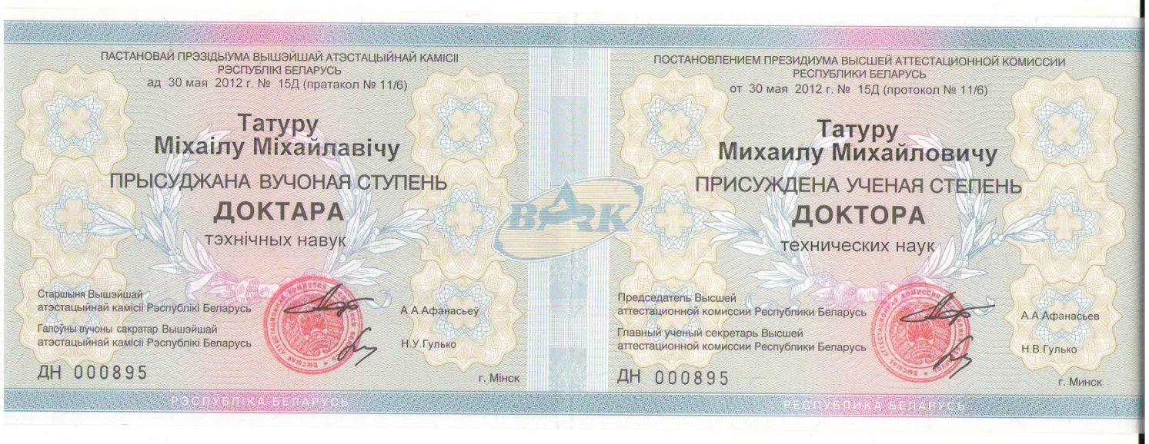
BY THE DECISION
OF THE PRESIDIUM OF THE STATE COMMISSION
FOR ACADEMIC DEGREES AND TITLES
OF THE REPUBLIC OF BELARUS
on May 30, 2012 No.15Д (record No. 11/6)

MIKHAIL TATUR

Is awarded the Academic Degree

of the DOCTOR
of Technical Sciences

Chairman of the State Commission
for Academic Degrees and Titles
of the Republic of Belarus /signature and stamp/ A.A. Afanasyev

Chief Scientific Secretary
of the State Commission
for Academic Degrees and Titles
of the Republic of Belarus /signature/ N.V. Gulko

ДН 000895 Minsk
Republic of Belarus

The text above is presented in two languages: Belarusian on the left, Russian on the right.

Translation is correct.
International Relations Department Head
Belarusian State University of
Informatics and Radioelectronics Elena Bakunova

